Critical Participatory Action Research—Models

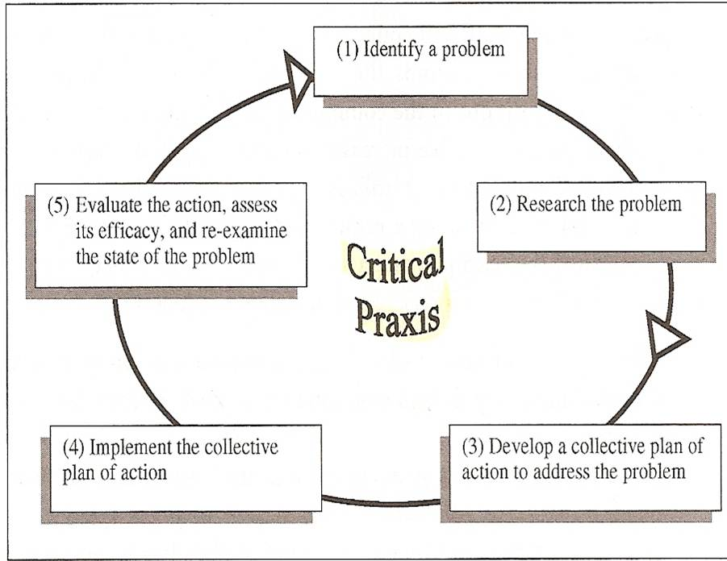

The Cycle of Critical Praxis
from Duncan-Andrade, J. & Morrell, E. (2008) The art of critical pedagogy: Possibilities for moving from theory to practice in urban schools. New York: Peter Lang. (p. 12)

Polling for Justice- Public Science Project in NYC, publicscienceproject.org
- The problem | Youth affected by negative consequences in education, healthcare, housing and criminal justice for youth
- Research | Poll over 1,000 NYC youth
- Plan of action | Theater performance based on research for audiences in NYC
- Implementation | Present and raise dialogue with audiences

School Climate Research – Humanities Amped
1) The problem | The problem is that the school’s power structures focus on compliance instead of learning and success because student voice does not adequately contribute to McKinley’s school climate.
2) Research | We surveyed 631 students at McKinley High to document student voice regarding problems and successes at McKinley. We also conducted 9 story circles in other classes at McKinley to document student voice regarding improving McKinley.
3) Plan of action | We will use the data from these surveys and story circles to create a document that lays out the findings regarding student voice to use for professional development for the faculty and staff. Students will use this document as text to facilitate dialogues with the faculty and staff in order to contribute student voice to school climate.
4) Implementation | This action plan will likely be implemented in May and hopefully will continue through next year; in other words, there will be an ongoing cycle of implementation and new research leading to a new action plan until student voice is fully incorporated into the power structures at McKinley.

Hegemonic Masculinity in Black Communities- Tyeone
- The problem | The problem this research project addresses is hegemonic masculinity and specifically how it affects black communities.
2)-4) Research/Plan of Action/Implementation | I plan to create a club for black male students at McKinley. Through the club, I can participate in group study and use intensive note-taking to gather information throughout my  experience. I can use secondary research to grasp a quicker understanding of root causes for the issue. I also plan to create a survey that can gather information about the comfort levels of the same students in situations where they aren't adhering to hyper-masculine standards.

Multicultural Awareness Among High School Students— Vincent
- The problem | There is a severe lack of multicultural understanding engrained in high school culture due to lack a of multicultural awareness.
2)-4) Research/Plan of Action/Implementation | I will be building a workshop to add to the Standing at the Intersection curriculum, facilitating the History Under Erasure: Youth Voice on Mute workshop, and giving a survey before and after the workshop. This initiative is meant to improve multicultural understanding through increasing multicultural awareness in a workshop entitled History Under Erasure: Youth Voice on Mute which will address how youth have been raised to accept a culture of silence throughout history and seeing how that affects the student body in the long term.

Ignorance of Depression within the Black Community— Victoria
- The problem | My topic for my senior project has been Ignorance of Depression within the Black Community. The reason why I chose this topic is because I am a part of the Black community. It seems like since I’ve been little people of my race have always had a way of ignoring depression.
2)-4) Research/Plan of Action/Implementation | My methods for uncovering this problem for my research have been surveys. It consisted of questions that would involve a personal opinion which is what I need considering that my topic is based on others opinions and how they feel about my specific topic. I was also thinking of using interviews as another way to get information from the public, but I decided if I were to do that I would only do about two interviews with people of different age groups. The reason why I would like to interviews to capture the emotion and reaction of the interviewee. Another method I would like to do would be to have multiple presentations in different classes about depression within the black community. I would like to talk about where it came  from, why it is ignored, ways that victims can get help, how to help a friend if they are hurting from the problem. My plan is basically to make depression within the black community a topic.

